**PHP Advanced Tasks**

**PHP Form Validation** Duration: 5 Hours

Create a simple Login and Sign up pages, you can use bootstrap for styling your pages, you should follow the below design, all the inputs should have validation in the frontend [regex] and the backend on both sides.

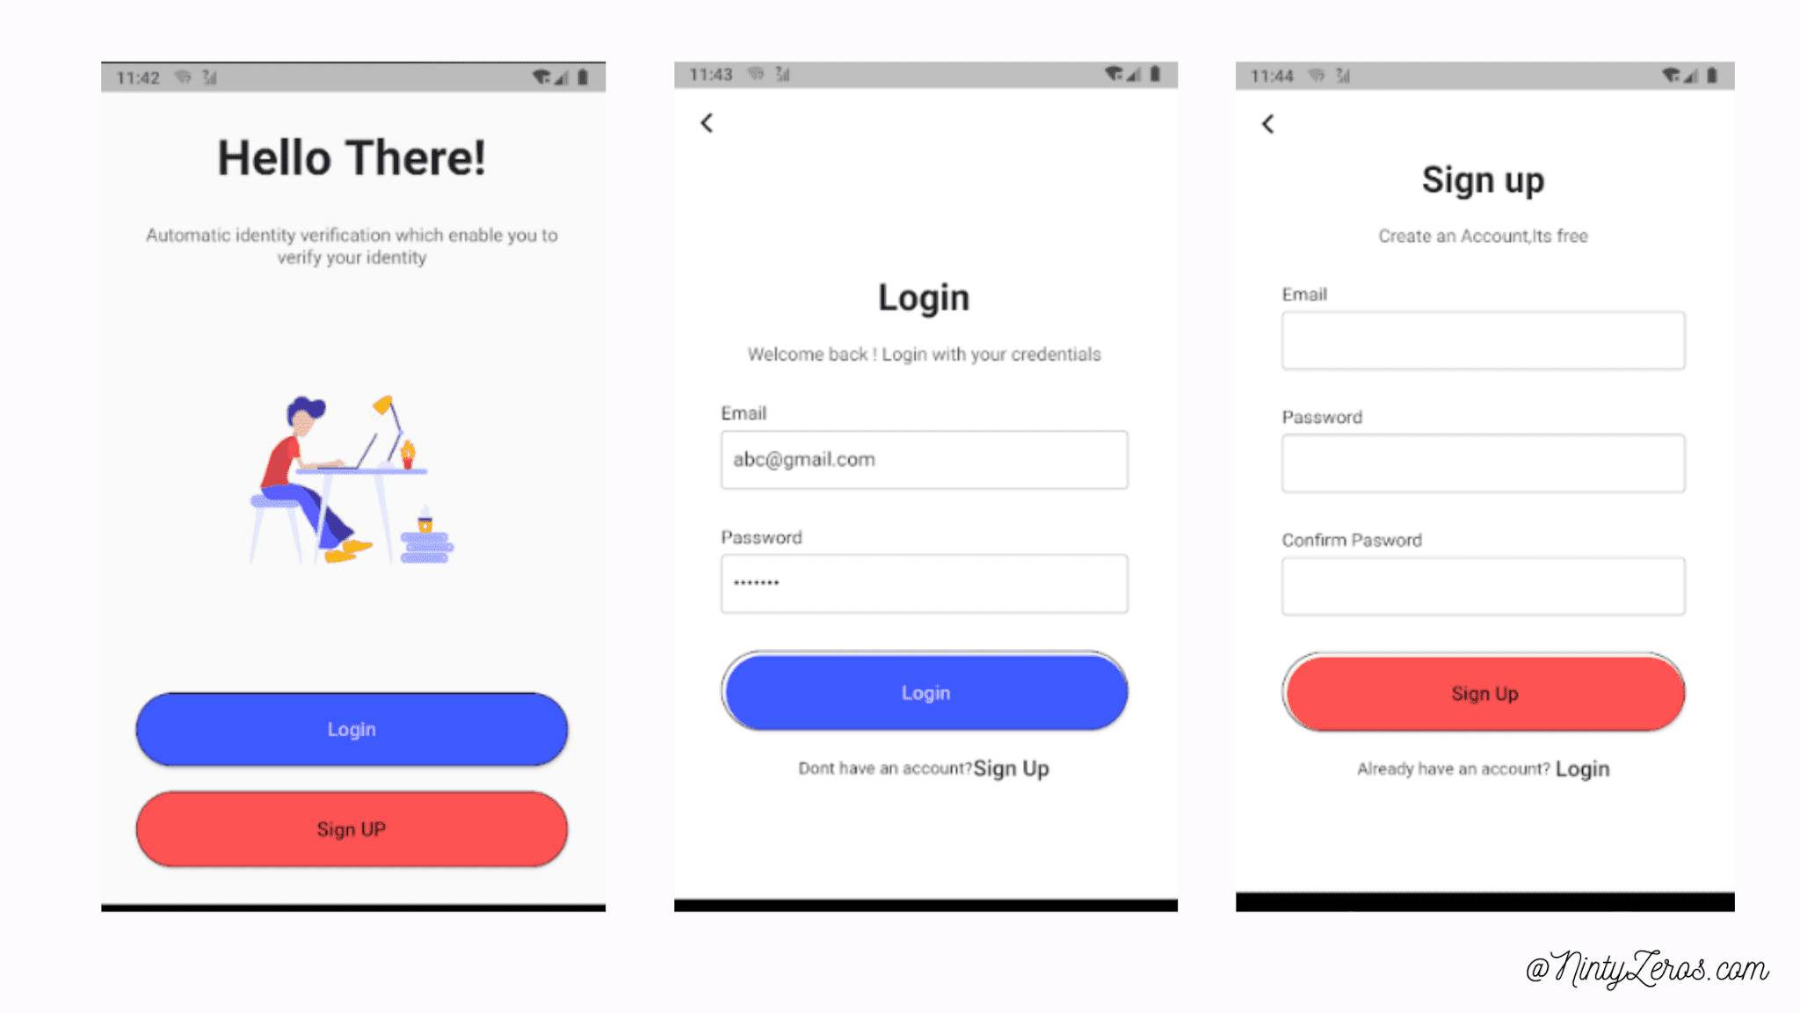

1. **Landing Page**

Your landing page will contain a welcoming message and two links one for the login page and the other one for the sign-up page

**2. Sign up Page**

Create a signup page containing the following input, all the inputs should be required and have validation as below:

* + Email: Should be an email input and follow the email pattern [regex] also the email is required
  + Mobile: Should be 14 digits also this field is required
  + Full name: Should be in 4 sections fname, middle name, last name, family name validation must be done to make sure he entered a text
  + Password: The password should be at least 8 characters and this field is required and should cover password strength rules such as (upper case, lower case, numbers, special character, no spaces )
  + Password Confirmation: The password should match the above field [Password]
  + Date of Birth: The date of birth should contain three fields Day, Month, Year (DD, MM, YYYY) if the registered above 16 years old he can register else error appear

**3. Login**

After the user is registered his information should be stored in an associative array. The inserted information in the login form **must match** the signup, if all the information is validated the user should be redirected to the welcome page otherwise an alert message will be displayed.

**4. Welcome Page**

The user will be redirected to this page if his information is valid, this page will display the user email and static welcoming message

**5. Admin Login :**

create a superuser, this user can log in from the same admin page after he logged in he can see this table :

|  |  |  |  |  |  |  |  |
| --- | --- | --- | --- | --- | --- | --- | --- |
| ID | Name | Email | password | date created | date last login | Edit | Delete |
|  |  |  |  |  |  |  |  |
|  |  |  |  |  |  |  |  |
|  |  |  |  |  |  |  |  |

The super admin can do all these functionalities:

1. View all registered users
2. Edit any of these users
3. Delete any user

Hint: **You can use all the topics you learned on PHP for the last two weeks.